Assignment

Watermarking images

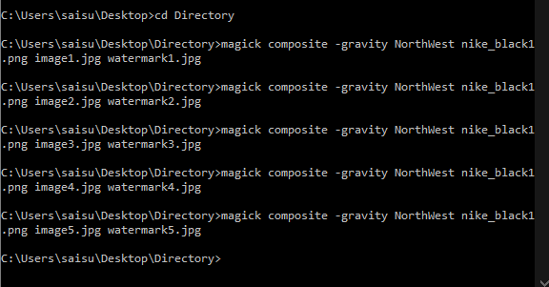

Magick composite -gravity NorthWest nike_black1.png image1.jpg watermark1.jpg

Magick composite -gravity NorthWest nike_black1.png image2.jpg watermark2.jpg

Magick composite -gravity NorthWest nike_black1.png image3.jpg watermark3.jpg

Magick composite -gravity NorthWest nike_black1.png image4.jpg watermark4.jpg

Magick composite -gravity NorthWest nike_black1.png image5.jpg watermark5.jpg